Intermission at Cambridge: Report

Foreword
Intermission is so often the elephant in the room in University-wide discussions of student mental health and welfare. Many issues impacting the welfare and wellbeing of students are in one way or another linked with the intermission system. However, as of November 2022, no substantial plans for supporting intermitting students have been made within the scope of the University’s Strategic Review of Mental Health, ‘Suicide Safer Strategy’ or numerous other areas of work aimed at supporting students’ welfare, safety, and academic attainment. This is despite student representatives regularly raising that consideration of the intermission system and students who intermit should be integral to all this work.

We know, through the large number of students who contact Cambridge SU’s Sabbatical Officers and our Student Advice Service with issues relating to intermission, and now through this research, that the intermission system is not working as well as it could for students. (1) This research confirms that intermission is widely valued by students as an option but that there are extreme disparities between the experiences of intermitting students and common feelings that the system is not well integrated with other forms of support available at Cambridge, and is often not effective in supporting the welfare of students.(2) Given that mental health is the leading factor students have identified contributing to their intermission makes it all the more urgent that intermitting students are considered within the University’s ongoing Strategic Review of Mental Health. The finding that students with disabilities, including Specific Learning Differences (SpLDs), autism, mental health diagnoses, and chronic illnesses are often not receiving support from central services prior to intermission is also particularly concerning; further research might focus on how well the collegiate University is meeting its legal duty to provide reasonable adjustments for these students.

We hope this research will prove the starting point for concerted work between the University, colleges, and Cambridge SU to improve the system together. To address the issues highlighted in this report, we need to standardise the intermission process across colleges; increase the welfare and financial support provided to students on intermission; and a shift in mindset about how we provide support at the University of Cambridge for students with more complex long-term needs.

Ben Dalitz (Welfare and Community Officer 2021-22)
Daisy Thomas (Welfare and Community Officer 2022-23)
Elia Chitwa (Disabled Students’ Officer 2022-23)

Contents
Executive Summary 4
Background 5
Methodology 6
Findings 8
Attitude towards Intermission 8
Support Prior to Intermission 9
Process of Intermission 13
Welfare and Support During Intermission 16
Finance During Intermission 18
Employment During Intermission 20
Housing During Intermission 21
Access to University Life, Spaces and Resources During Intermission 23
Returning From Intermission 25
Alternatives to Intermission 27
Discussion: The Key Findings and Recommendations 29
Finding #1 The process of intermission is disparate and unpleasant to navigate 30
Finding #2 Lack of welfare support: prior to, during, and after intermission 31
Finding #3 Lack of financial & housing support 33
Conclusion 34
Endnotes 32
Appendix A 36

Executive Summary
This report provides insight into the student experiences of the intermission process using data gathered from a Cambridge SU survey on intermission that was open to all Cambridge University students and alumni.

The first key finding of this report is that the process of intermission is disparate and unpleasant. 44% of respondents disagreed that the intermission system is fair, and many students reported that uncertainty, difficulty or worries about the intermission process often exacerbated the difficulties they were facing.

The second key finding is that there is a lack of welfare support prior to, during, and after intermission. 75% of respondents disagreed that intermitting students are adequately supported during intermission. Several central University services, such as the University Counselling Service, are not available to intermitting students. Even after returning from intermission, many respondents reported feeling lonely and only 45% agreed they were able to find community upon returning.

The final key finding is that there is a lack of financial and housing support for intermitting students. There was evidence of significant financial hardship among intermitting students, with a third of respondents having concerns about paying for basic costs like food and accommodation. Additionally, students who would usually be eligible for the Cambridge Bursary do not receive this payment during intermission. There is also limited access to other means of University financial support for students on intermission

Overall, this report provides recommendations that fall into 3 main categories:
- Standardising the process of intermission with colleges and the University collecting consistent data on all aspects of the process and publishing standard information on the intermission process.
- Improving the welfare provisions for intermitting students by providing orientation meetings to students at the beginning and end of intermission, designating a pastoral figure to stay in regular contact during a student’s intermission and granting intermitting students access to central University services.
- Improving the financial and housing support available to intermitting students by ensuring they have access to sufficient funding and retain their current entitlements, granting students the right to stay within University accommodation if they would otherwise return to unsafe or unstable environments, to revoke any restrictions on intermitting students’ whereabouts, and to end attempts to stop intermitting students taking paid work.

Background
Intermission, also known as ‘disregarding terms’, is the process whereby students can take time out from their studies for medical reasons or other grave ‘serious’ causes. (3)

Both undergraduates and postgraduates can intermit, although the processes for doing so are different. In the case of undergraduate students, the student’s college must submit an application to intermit on their behalf to the Examination Access and Mitigation Committee (EAMC) who will decide whether to approve it. The majority of postgraduate students can apply directly for a medical or non-medical intermission, with the latter allowing them to take parental leave, and pursue opportunities such as research fellowships and internships, etc. Postgraduate applications are received by the Student Registry who will decide whether to approve it, taking into account approval from the student's College Tutor, Supervisor, Department, Degree Committee and, in the case of medical intermission, also advice from a Medical Advisor.

Some students intermit following a college Fitness to Study (FtS) process (which differs across colleges) or the university’s Capability to Study process. College and University processes are all recognised by the EAMC.

Cambridge SU decided to conduct research into the intermission system for two reasons: Firstly, we were commonly hearing of difficulties faced by students relating to the intermission system, ranging from difficulties with finance and housing during intermission, to stories of forced intermissions, and we wanted to know how common these anecdotal experiences were among past and present intermitting students. Secondly, intermitting students represent a major gap in existing research and are therefore overlooked within University policy work. There is little comprehensive information available about how intermission functions across the collegiate University and what support is being made available at different colleges. The University of Cambridge recently undertook research into student mental health and wellbeing to inform its Strategic Review of Mental Health, studying the services, systems, and provisions that currently exist for students. However, intermitting students and the intermission system were not included within the scope of this research. Since many students intermit for reasons relating to mental health and welfare, we wanted to begin the process of gathering data so that intermitting students can be considered within the conversations that are taking place about improving and restructuring how support is provided to students.

Methodology
Our research aimed to understand how intermission is currently being used at the University of Cambridge and its colleges, how students perceive it, and how students would like the intermission process to work.

We conducted our research by means of a survey, which was open from Wednesday 4th May to Monday 13th June 2022. Students were encouraged to complete the survey via posts to Cambridge SU’s website, email bulletin, Twitter, Instagram and Facebook pages, as well as via targeted posts in Facebook groups for intermitting students and disabled students.

The survey was open to all students at Cambridge at any level of study as well as alumni, whether or not they had any personal experience with the intermission system. We asked students what experience if any they had of the intermission system via tick-boxes, and the survey was designed so that respondents would only be shown sections relevant to them (e.g. only students who were intermitting or had done in the past would be asked about their experiences during intermission, only students who had returned from intermission would be asked about how they were supported on their return). All respondents were invited to complete the sections on Attitudes to Intermission and Student Visions for the Intermission System.

We made respondents aware of our data protection policy and allowed them to opt in or out of the publication of quotes from their open text responses. (4) All respondents confirmed that they were happy for their data to be stored and used in accordance with our data protection policy. All subsequent sections were optional to answer. In recognition that they might recall difficult experiences while filling out the survey, we signposted a directory of welfare resources as well as our Students Advice Service and other sources of information about intermission.

The survey received 350 responses. Percentages are given to 2 significant figures throughout.

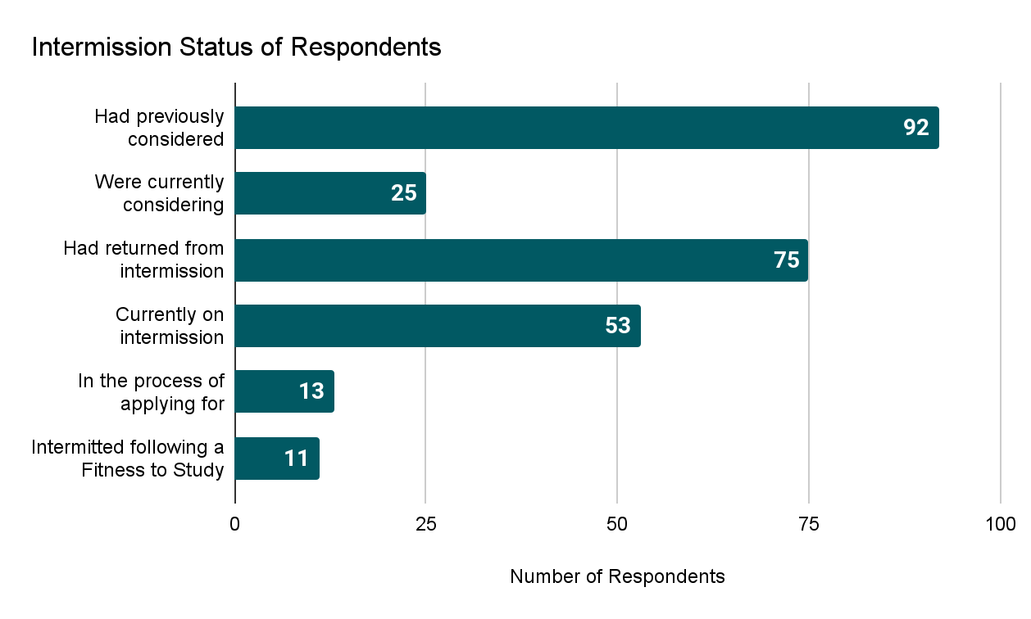

Findings

Attitude towards Intermission
Almost all respondents (95%) agreed or strongly agreed that intermission is an important option for supporting the welfare of students. However, most respondents felt that intermission is poorly integrated into Cambridge’s broader provisions of welfare support (60%) and academic support (63%).

A substantial minority (44%) disagreed that the intermission system is fair; and just over half (54%) disagreed that the intermission system respects the agency of students.

None of the 11 respondents who intermitted following a Fitness to Study process agreed that the intermission system is fair.

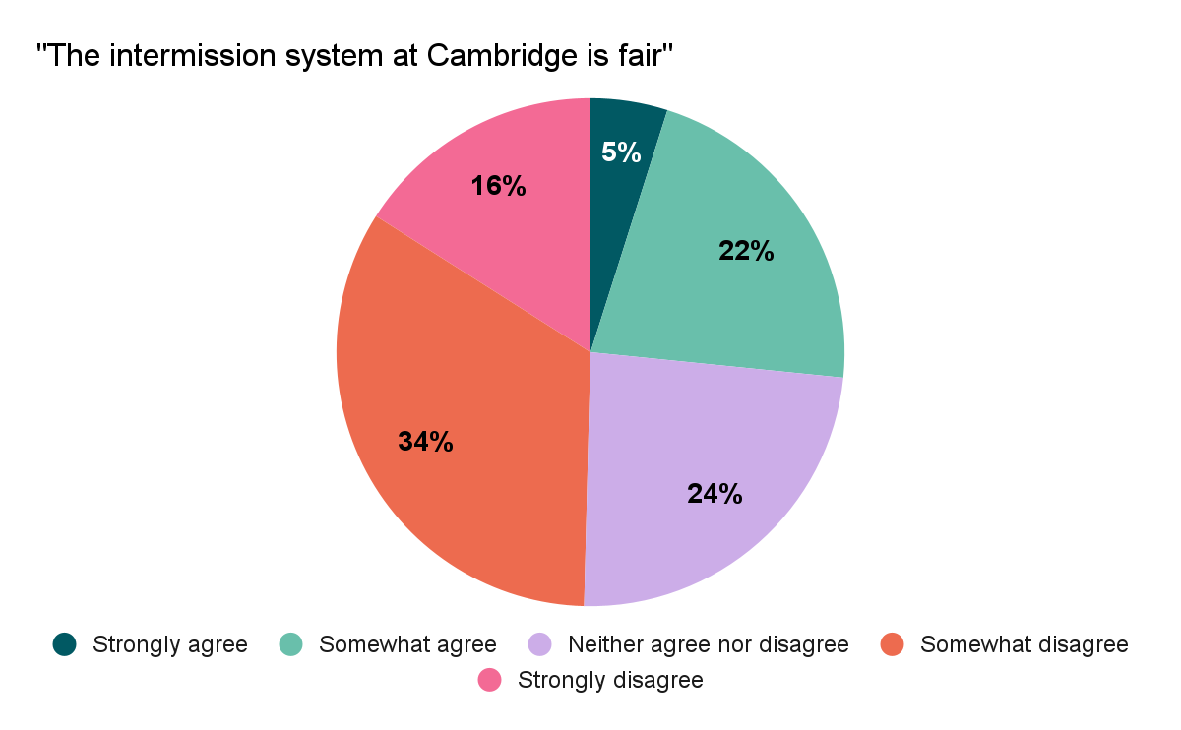

Support Prior to Intermission
The forms of support most commonly accessed prior to intermission were support from the University Counselling Service (UCS) or a college counsellor (18%), health and welfare support provided by college nurses (18%) and academic support from a Director of Studies and/or faculty (18%).

Only 1 in 10 (11%) accessed support from the Accessibility and Disability Resource Centre (ADRC) prior to intermission. (5)
- Of the 99 students who disclosed to us that they have a mental health condition, e.g. depression, schizophrenia or an anxiety disorder, 24 (24%) had accessed support from the ADRC, and only 15 (15%) had accessed support from the Mental Health Advisors (MHAs) prior to intermission.
- 77% of those who disclosed to us Autistic Spectrum Disorder or Asperger’s Syndrome, 75% of those who disclosed to us an SpLD such as dyslexia, dyspraxia or ADHD, and 64% of those who disclosed to us a long-standing illness or health condition such as cancer, HIV, diabetes, chronic heart disease, or epilepsy had not accessed support from the ADRC prior to intermission.
- Those with a physical disability or mobility issues were most consistently accessing support from the ADRC (80%) prior to intermission.

A small number of students (6.6%) had accessed support from the Mental Health Advisors.

An overwhelming minority (0.69%) explored Adjusted Modes of Assessment, e.g. long extensions or replacing written examination with an essay. 11% had been offered Examination Access Arrangements (EAAs) e.g. rest breaks, 25% extra time, or dictating exam answers. Just 2.4% had explored the option of Extended Period of Study a.k.a. “Double Time”.

We gave respondents the opportunity to comment on how they were supported prior to intermission. Respondents again highlighted that the quality of support they received often hinged on individual staff in colleges. One student commented that they received support “mostly because I had an absolutely fantastic tutor. Important welfare decisions should not become a lottery based on whose tutor is most supportive”.

Students who felt well supported particularly appreciated college pastoral staff helping them to explore their options and explaining processes to them, and support (including financial support) to access neurodiversity diagnoses and counselling.

Many students reported that their problems were not picked up at an early stage. This was commonly linked to lack of contact with their DoS and tutor. Some noted that the onus was on students to reach out for support. Several students, including undergraduates, had never met their tutor. Others reported that pastoral meetings were too brief to provide meaningful support.

Several students said that concerns they tried to raise at an earlier point were “ignored”, “not taken seriously” or that their colleges were “dismissive”. Some students had been discouraged from attempting to access Double Time, reasonable adjustments, and extensions by college staff; some students noted that the advice of college staff conflicted with that given by their ADRC advisor.

Reasons for intermission

Out of the 137 respondents who had previously or were currently going through the process of intermitting, the most common primary factors respondents identified as contributing to their intermission were mental health concerns (55 respondents), a flare up of a medical condition (21 respondents), and major traumatic incidents (10 respondents).
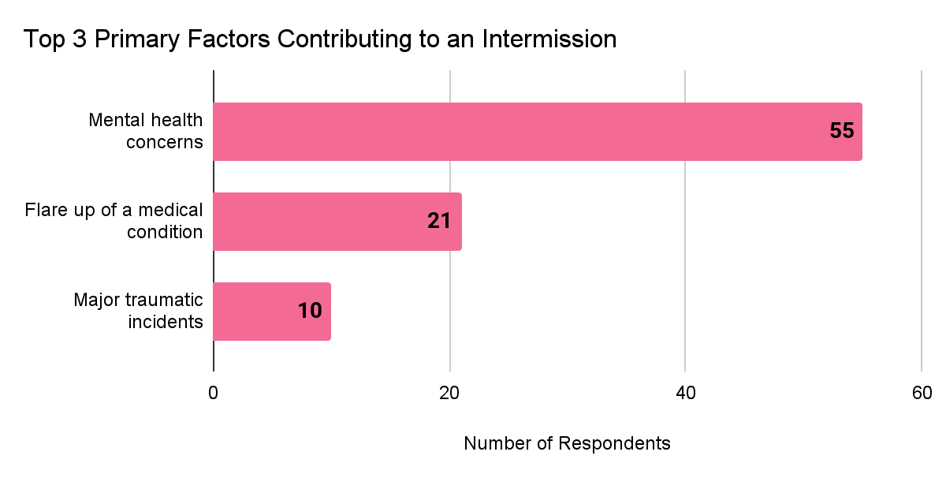

Common secondary or tertiary factors were academic concerns (30 respondents), workload (28 respondents), mental health concerns (24 respondents), major traumatic incidents (20 respondents), and a flare up of a medical condition (19 respondents). 11 students listed bereavement as the primary or secondary factor in their intermission. A small number of students listed discrimination and reasonable adjustments not being met as contributing factors in their intermission.

Respondents were given the opportunity to expand on their reasons for intermitting, and several went into further detail about college mishandlings of cases of sexual violence and racism, including cases in which victims were pressured to intermit following a sexual assault, and cases in which colleges failed to take disciplinary action following reports they made.

Respondents were asked what they thought the main purpose of intermission is currently.

Some identified responding to student welfare issues as the main purpose of intermission. Common responses were to “recover” and to “give students a break”. However, many felt that intermission was currently an ineffective welfare measure.

Some identified support with academic needs as the main purpose of intermission, but this was much less prominent. This featured mostly as a secondary consideration, with some feeling that intermission could provide a “break from the stress and the workload” of University so that students could “reprioritise life”. Intermission gave students time out from studying at Cambridge “when you’re not well enough to make the most of it or perform at a level representative of your actual ability”.

Others valued the opportunity non-medical intermission provides PhD students to take up internships and short term professional engagements. A few responses highlighted the value of non-medical intermission in allowing graduate students to pursue career opportunities.

Some students were frustrated that they felt staff perceived intermission as purely an academic measure; one student who wanted to intermit to recover from illness said that their college “discouraged me from doing so even while I was very ill and often in hospital, and only suggested I intermit when it was clear I wouldn’t pass my exams”. Many referenced Cambridge’s intense academic environment as a reason that students intermit.

Process of Intermission
Seven out of ten respondents who had intermitted agreed that that it was their choice to intermit (71%), that staff involved in their intermission process had their best interests at heart (67%), that medical professionals and medical evidence were involved at appropriate points (77%), and that intermission was the most appropriate solution to the problems they were facing at the time when they intermitted (69%). 13% disagreed that intermission was the most appropriate solution to the problems they were facing at the time when they intermitted, and 17% disagreed that it was their choice to intermit.

All those who reported that it was not their choice to intermit were undergraduate students.
Half of students disagreed that it was made clear to them where they could appeal, if they disagreed with a decision relating to their intermission (52%). Around a third (35%) disagreed that the intermission process was explained clearly to them at the outset of their intermission.

- Of those who felt it was their choice to intermit:
  - 90% felt listened to by college administration;
  - 81% agreed that staff had their best interests at heart;
  - 70% agreed that medical evidence was involved at appropriate points;
  - 88% felt that the intermission process was explained clearly to them at the outset; and
  - 83% felt that intermission was the most appropriate solution to the problems they were facing at the time when they intermitted.
- Of those who who felt intermission was the most appropriate solution to the problems they were facing at the time when they intermitted:
  - 83% felt the process was explained clearly at the outset;
  - 86% felt listened to by college administration;
  - 80% felt that staff had their best interests at heart; and
  - 73% agreed that staff kept them informed about the progress of their application and responded promptly to their questions.
- Of those who reported that it was not their choice to intermit:
  - 34% disagreed that the intermission process was explained clearly to them at the outset;
  - 67% disagreed that medical professionals and medical evidence were involved at appropriate points; and
  - 63% strongly disagreed that the intermission system at Cambridge respects the agency of students.
- 50% of those who intermitted following a Fitness to Study Process disagreed that it was their choice to intermit.

We asked how the process of intermission could be improved for students. Many answers focussed on levelling disparities in experiences and establishing a “university wide minimum standard for the processes of intermission and the support given”. Some felt that the process is too “bureaucratic”, with one student commenting that it “shouldn’t be so formalised in a panel having to decide whether you’re worthy of intermission”.

Another common response was a desire for greater student autonomy over the process. Some students told us they want an intermission process which is less “punitive and restrictive” and “only used when the student is in agreement”. Respondents commonly felt that the process could be improved by lowering or removing the requirement for evidence and “trusting the students to be able to tell when they need to stop”. The Fitness to Study procedure was described by one respondent as “cruel, inhumane and bureaucratic”, commenting that it “felt in my experience as if I was on trial, and fighting for my right to remain at the University”.

Students wanted information about the intermission process to be clear and readily accessible to students. Some suggested that there should be “an advocate or single point of contact” who can give information about the process, administrative support and make sure all relevant parties are kept in the loop.

Students did not find the procedures clear and transparent. Respondents characterised the intermission process as “opaque”, “stressful” and “disjointed”. Factors cited as contributing to this included the lack of clear timelines; difficulty finding information for students about the processes to intermit; and issues with communication between parties including the Student Registry, college staff and the intermitting student.

It was felt that the process is “unnecessarily onerous on the applicant”. Several students highlighted additional difficulties faced by international students acquiring medical evidence to support their application.

Uncertainty, difficulty or worries about the intermission process often exacerbated the difficulties students were facing. Some respondents described the process of intermitting as “humiliating”, “patronising” and “traumatic”. Students found waiting for outcomes stressful, especially if they were unsure whether or not they would have to sit exams or submit work. One respondent summarised: “At best the process is difficult at a difficult moment; at worst it compounds the student’s difficulties”. Students reported that the prospect of having to intermit against their wills put their mental and physical health under greater pressure. One student, commenting on recovering from illness during Cambridge term, said “I tried to keep going and start catching up long before my body was ready, and I ignored the indications that it wasn’t coping, and ultimately made myself more ill” because of the pressure to recover quickly or intermit. Others raised that the possibility of being forced to intermit created a barrier to talking about mental health issues: one student reported “feeling that I could no longer confide in anyone at the college about the true state of my mental health, for fear of being sent home”.

Students’ experiences were highly dependent on the responses of individual staff. Students felt this contributed to inconsistency across the collegiate University; for example, one student commented that the process of intermitting is “dependent on your Tutor's personal opinion regarding intermission [...] I was lucky to have very supportive Tutor & DoS, but some friends have experienced quite horrific responses from theirs.” Students who had built good relationships with key pastoral and academic staff early on found the process of intermitting smoother than those who hadn’t. One student commented: “I hadn't even met my personal tutor so reaching out to them about starting the intermission process felt extremely difficult. It's important that open, supportive relationships are established prior to difficulties occurring to enable communication”.

Welfare and Support During Intermission
Three quarters of students surveyed (75%) disagree that intermitting students are adequately supported during intermission.
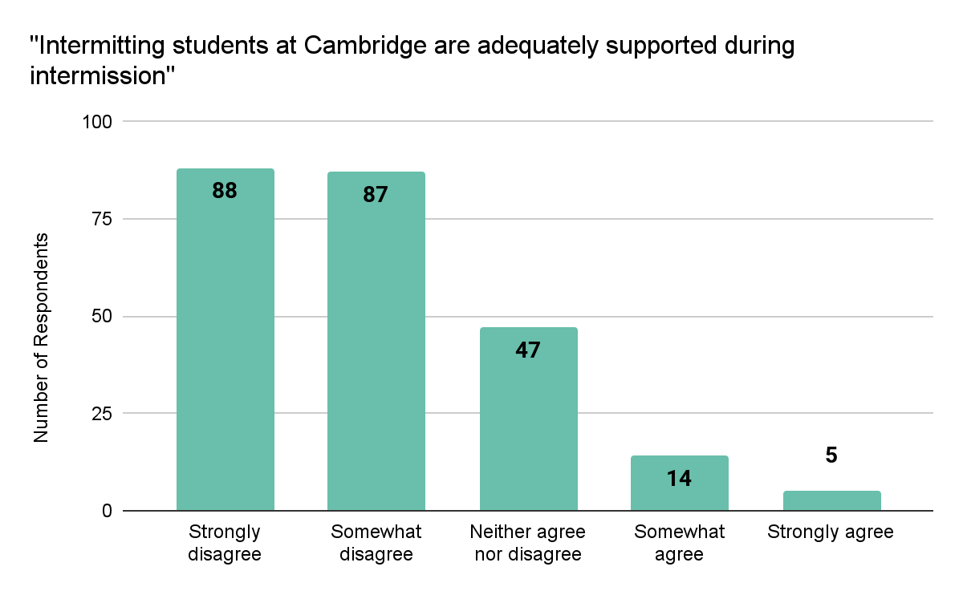

59% of respondents who answered this section told us that they had found support from their tutor moderately useful or very useful, and 52% told us they had found support from their Director/s of Studies useful.

Students commonly told us that other sources of support were not offered but would have been useful. This included support from a Mental Health Advisor (55%), the Student Advice Service (51%), counselling provided by their college (49%), the University Counselling Service (43%), and their college nurse (31%).

We gave respondents the opportunity to comment on welfare support during intermission. Most told us they were not proactively offered support, and many said that they had not received any communication or check-ins from college staff during their intermission. Some had attempted to access support both via colleges and central services; the majority were turned away from services but some students had received support from the University or colleges. Some criticised the narrow eligibility criteria for accessing the Madeleine Davis Fund (which allows intermitting students to be supported by UCS). Students at some colleges received funding for therapy. A few students said they had benefited from the support of the Disability Resource Centre and the University’s Sexual Assault and Harassment Advisor during their intermission. Some students had created their own peer support networks of intermitting students.

Students were asked what the main benefits of intermission could be. The overwhelming focus of responses was the welfare benefits of a welfare-focussed intermission system.
Students wanted intermission to exist alongside a number of options for supporting student welfare, and felt that some problems are more appropriately handled by intermission than others. Intermission was considered a good solution to “a temporary problem like a medical flare up”, and students felt intermission could provide an opportunity to “develop new coping strategies”, “access healthcare, adjust to medication, undergo intensive therapy” and “build a support plan for the next year”. There was an emphasis on recovery and putting better support in place for the following year

A large number of respondents highlighted the demand for better financial support, housing support, and welfare support, including access to the University Counselling Service and regular, consistent pastoral support from colleges.

Finance During Intermission
A third (34%) of respondents had concerns about paying for basic costs such as food and accommodation during intermission. This is likely to get worse given the current cost of living crisis.
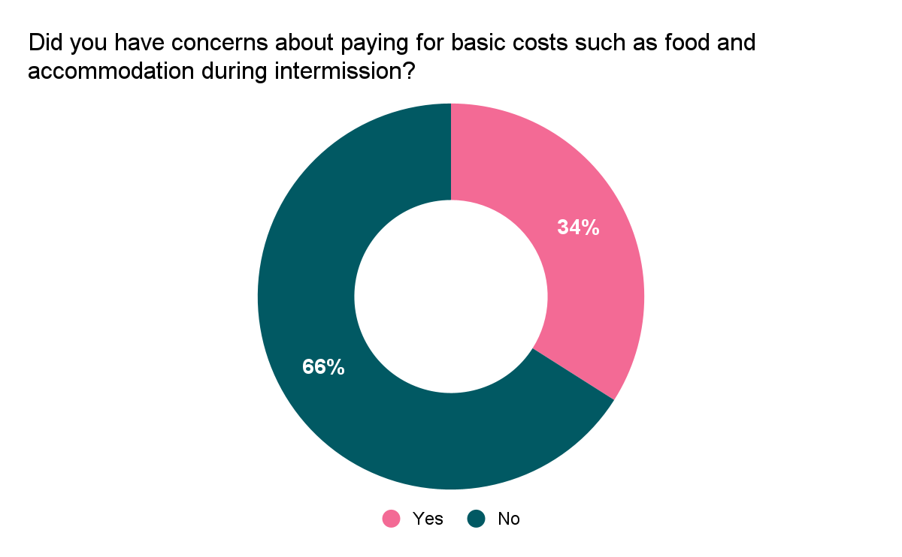

Over half (58%) of those who reported experiencing financial concerns were recipients of the Cambridge Bursary, which ceases to be paid to students while they are intermitting. Several students wrote that they struggled upon losing access to the Cambridge Bursary and wished this were available to intermitting students.

Those who accessed financial support during their intermission most often did so from college (13%) and the Crane’s Fund (11%), while fewer students had accessed the Special Hardship Fund (6.0%), benefits from the government (6.0%), or other government funding (4.8%). 22% of respondents identified other sources of support, including financial support from parents/family members and paid sick leave provided by PhD funding bodies. 30% of respondents told us that they didn’t receive financial support but it would have been useful to them. 4.8% told us that they applied for financial support but their application was rejected.

Some respondents reported difficulties accessing funding sources within the University. Some students missed funding deadlines because college staff did not submit applications on their behalf on time. One student said they were expected to take out a personal loan before they would be considered for college hardship funding.

There were large disparities in financial support provided at different colleges. Students who received funding from their college had most commonly been given support to pay for private therapy, with figures ranging from a few hundred pounds to a thousand pounds. Students at other colleges received no financial support from college, with one student commenting that knowing their college would not provide any financial support “was almost a reason that I could not intermit”.

A large number of students were reliant on financial support from family members during their intermission. One student described “​​an inherent, and incorrect, assumption that all Cambridge students can simply be sent back to financially secure, safe home environments”. Few other funding sources external to the University were available to students. Some had attempted to access Universal Credit but been rejected because of their student status. The small number who had received benefits told us that they were “not sufficient” to meet their needs.

Many students told us that they received insufficient, incorrect, or unclear information about what financial support they would be able to access during intermission. Many were not made aware of the Special Hardship Fund to which intermitting students can apply. Some PhD students wished they had been given clearer guidance about accessing sick pay as part of their stipend.

When outlining their visions for the intermission system, respondents wanted more information to be made available relating to Student Finance England, sources of funding for intermitting students, and how to take paid sick leave as a PhD student.

Employment During Intermission
Just under half (48%) of respondents had undertaken paid work during their intermission. 31% told us they were not well enough to work during intermission; 7.5% told us that they undertook paid work despite not being well enough to work during intermission and 19% told us that they were reliant on income from working during intermission.

17% of respondents told us that working during intermission had an overall positive impact on their wellbeing; while 11% reported that working during intermission had an overall negative impact on their wellbeing.

25 students (19%) reported that they had been told they were not allowed to work during intermission.

Some PhD students lost income from supervision work upon which they usually rely. Several students reported that the financial precarity they experienced during intermission was exacerbated by being instructed not to work. Some students also had received conflicting messages about working during intermission; one respondent told us, “I was told both that I was not allowed to work during intermission, and that I was expected to work”.

Housing During Intermission
A fifth (19%) of respondents disagreed or strongly disagreed that they had somewhere appropriate to stay during intermission.

58% of respondents returned to their family home and 10% returned to their regular out-of-term address. 9.3% found private accommodation during intermission. A very small minority stayed with friends (i.e. in someone else’s house), stayed in college, or did not have to move as they were already living in privately rented accommodation.

Several respondents used the open text field to tell us that they returned to their family home but had to move out part way through their intermission for their own safety.
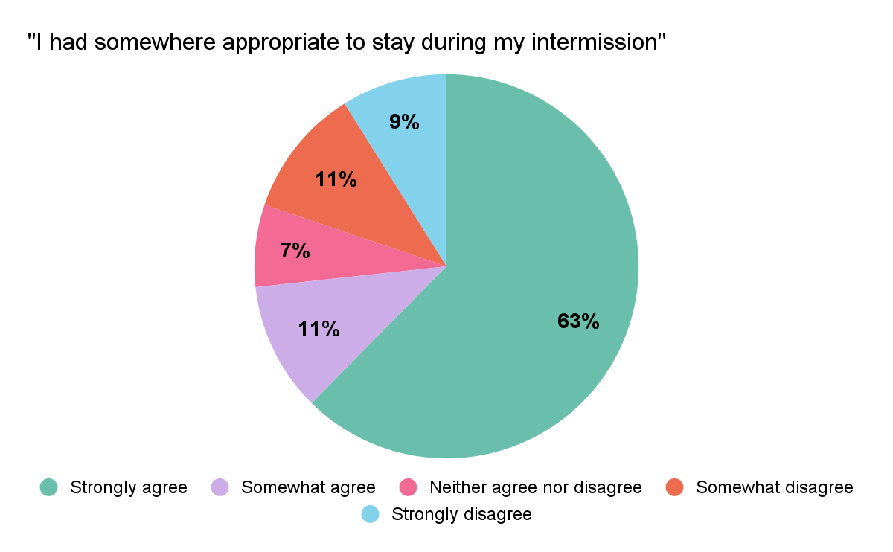

13% told us that their college obtained permission before communicating with family members or an Emergency Contact about their intermission, and 13% told us that their college did not. 30% wanted their college to communicate with family members or an Emergency Contact about their intermission, and 18% did not. There was a statistically significant coincidence (32%) between those who said that their college did not obtain their permission to communicate with family members or an Emergency Contact and those who did not wish for their college to do so.

Respondents were given the opportunity to comment on their housing and home situation during intermission.

- A significant number of responses were students telling us that their family home was not a safe place to be, or not a place in which their mental health could improve. One student told us, “Despite being very clear that my home situation was one of the causes of the mental collapse that caused me being forced to intermit, I was given no option but to return home. The college was fully aware of it”.
- Many students would have liked support to remain in Cambridge, e.g. the option to stay in college accommodation, financial support to find somewhere in the city to stay. Students often said that leaving the city would mean being cut off from the support they had. One student commented that they needed to stay in Cambridge as “that was where my friends and support systems were. And where I was receiving therapy”.
- Several respondents reported severe difficulties with housing during intermission. This included experiencing periods of homelessness. One student told us, “I could not have intermitted without financial support” due to issues with accommodation.
- Finding housing was more often a problem for undergraduate students on intermission, as Postgraduate students were more likely to be renting privately prior to intermission.

Access to University Life, Spaces and Resources During Intermission
22% of respondents were asked to vacate their student accommodation. Of those, just 33% were given clear notice of the date by which they should vacate their accommodation. 88% of those asked to vacate their student accommodation were undergraduates.

19% of respondents were told they should not access college spaces, while 18% were told they should not access libraries, and 16% were told they should not access University spaces. 8.5% were not given any restrictions on their access to spaces in Cambridge. 19 of the 138 respondents to this section (7.7%) had been told they should leave the city of Cambridge. Undergraduate students were more commonly given restrictions on their access to University and college spaces than those at other levels of study.

Whilst almost all (99%) retained access to their University email during intermission, just over half (56%) had access to Moodle and other virtual learning resources during intermission, while 11% did not have any access and 33% were unsure whether or not they had access.

Only 15% of respondents agreed that their college made them feel like they were still a part of their community while on intermission. Under half (38%) said that college staff stayed in touch with them during their intermission.
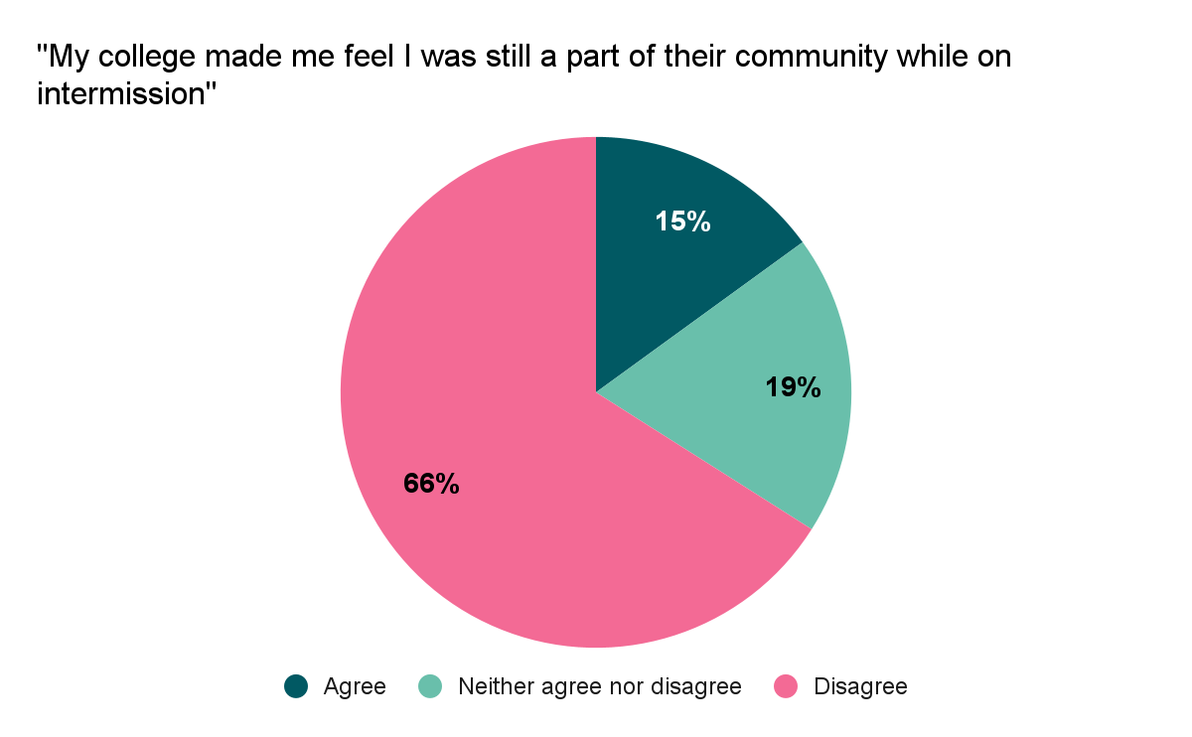

Undergraduate students more commonly reported feeling isolated from their college community: 64% of undergraduate students and 38% of Postgraduate students didn’t feel that their college made them feel they were still part of their community while on intermission.

Many respondents wanted to see an end to the practice of banning students from entering college premises while intermitting.

Students felt that opportunities to remain part of their college community and see friends would benefit their welfare during intermission and make it easier to return from intermission.

Intermission often results in a loss of access to support, community and resources. Students reported being cut off from friends in their year group, receiving little or no support from college pastoral figures upon intermitting, and being left in ambiguous positions with regard to finance. Many were distressed at having to leave college: “to be essentially evicted while in a very difficult and distressing time seems an obvious bad thing”. Students felt that they were “off the radar” once they intermitted. One student commented: “It felt like the tutorial staff at my college just wanted to get rid of me for a year. To palm me off on someone else so I wouldn’t be their problem anymore”.

Returning From Intermission

The Process of returning
65% reported that their return from intermission was made conditional on a reassessment of their fitness to study (typically separate from a Fitness to Study procedure). 23% reported that their return was conditional on them providing a letter from a GP or other medical evidence.

One respondent described: “I was on the incorrect mailing lists, my college bill was unclear, I was considered neither a second nor third year and not invited to any events. My camcard was disconnected from my upay and from libraries so I couldn't take out books or pay for things”. Others told us that they received last-minute notice of deadlines for evidence to return from intermission, that college staff were unable to give them guidance about reapplying to Student Finance England (SFE), and that they had to proactively reach out for the information they needed about their return.

Many students wanted staff to support them to develop a plan to avoid the circumstances that had led to their intermission recurring. Some students had received good support of this kind from their tutor, DoS, college chaplain and from the ADRC. One respondent suggested that “a one-off 'managing your return' appointment with a mental health professional/college advisor might have been useful” before their return from intermission, while others had valued regular meetings during their first term back. Most respondents had received little to no welfare and academic support around their return.

Social reintegration
45% agreed that they were able to find community upon returning from intermission, while 36% disagreed. Undergraduate students more often disagreed. Students commented that their return felt “lonely” and “isolating”. Many felt that they were not supported to make friends in their new year group, for example being housed away from others in their new year group and left out of freshers’ week events, year group photographs and dinners.

Several students said they would have benefitted from the option of a more gradual return, for example one commented: “my GP had said I should do a phased return but there was no process to support this”.

Academic reintegration
45% agreed that they felt supported to return to their studies after intermission, while 28% disagreed. Undergraduate students more often disagreed. One student commented: “As I returned part way through the academic year, I was out of step with my classmates and college life. I received no support to help me catch up on Michaelmas term work which I had missed due to illness prior to intermission”.

One student commented that they “felt in between years”. Another said that this also led to isolation in their academic life as they had “no way of knowing who was on my course”. Some respondents also said that having intermitted intensified the imposter syndrome they experienced within the University on their return.

One respondent suggested that they “would have benefitted from ‘revision’ or ‘catch up’ type meetings with my DoS or supervisors before returning”.

Alternatives to Intermission
A recurring theme in the responses was that intermission was treated as an individual solution to a wider problem of overwork and lack of flexibility in the Cambridge degree. One student commented, “after just two weeks of being too ill to work, it already seemed clear that I would either need to make a total, immediate recovery and then work extra hard to catch up (not easy when you’ve been unwell), or I’d have to leave, spend many months in limbo, and start all over again”.

One response referred to intermission as a ‘plaster’ to ‘cover the fact that many people fall ill or behind on work for many reasons and have limited opportunities to catch up due to the shortness and denseness of the terms and the amount of work expected during vacations.’ The student went on to say that “if the term structures were more forgiving and allowed for a greater margin of error, it might be possible to have fewer intermissions. If there were other, less drastic in-term allowances for people with chronic/severe ill health (i.e. reasonable reductions in workload), this might mean we could complete the course without extreme gaps”. Another summarised, “if you ask for support AT the University, you are presented with the option of having a year AWAY from the University”.

Several felt that they would not have needed to intermit if alternative support had been provided. One student commented: “I do not think I would have had to intermit if I had been listened to and supported sooner. The university did not seem to care about my disability or health conditions until I was at breaking point and could no longer continue studying.” Another respondent told us, “I really didn't want to intermit – it was the only option I was given in lieu of being given adequate medical support and provisions to continue my study”.

Intermission was compared by one respondent to giving “struggling students a break before strapping them back to the rack in the hope they’ll stretch out next time rather than breaking again”. One such example was a student who wrote that, upon their return to from intermission, they “felt as though I had complete responsibility to develop my own plan alongside my care team at home, when things that would have been exceptionally helpful (Crane’s funding therapy and AMAs such as Double Time) should have been offered and discussed, particularly as the circumstances that lead to my intermission were particularly severe. I ended up not being able to sit my exams the next year due to the same reason because I didn’t have enough support in place, and have only now been able to manage this year due to finding out about Crane's funding and Double Time myself and sorting it out myself”.

Half of students disagreed that they were made aware of options available to them other than intermission (50%). An overwhelming minority of respondents (0.69%) explored Adjusted Modes of Assessment, e.g. long extensions or replacing written examination with an essay. 11% had been offered Examination Access Arrangements (EAAs) e.g. rest breaks, 25% extra time, or dictating exam answers. Just 2.4% had explored the option of Extended Period of Study a.k.a. ‘Double Time’. This is likely consistent with low numbers accessing these options across the University, e.g. in the academic year 2020-21, 74 people requested and 52 were approved for AMAs. (6)

Students felt that there were other problems that intermission will not resolve that require other support options; e.g. one student felt that “many students are pushed into intermission when Double Time would be more appropriate”.

Discussion: The Key Findings and Recommendations
The major findings of our research were:

- The process of intermission is disparate and unpleasant to navigate.
- That there is a lack of welfare support for students prior, during and upon return from intermission.
- That there is a lack of financial support for students on intermission.

Beyond the scope of just intermission itself, our research also found that there are wide-spread issues with the way that the university handles student welfare in relation to the academic expectations. Students who intermitted were often not receiving support prior to intermission, and other options for adjusted study are not utilised. It is crucial that any long-term strategy for improving the intermission system includes expansion of alternative modes of assessment and study.

Finding #1 The process of intermission is disparate and unpleasant to navigate
Our findings show that the experiences of students intermitting, applying to intermit and returning from intermission vary hugely across the collegiate University.

Respondents’ experiences of intermission were highly dependent on the knowledge and attitudes of individual members of staff, especially tutors. There was wide variation in the availability of college funding, with some colleges able to support students to access therapy during intermission while other colleges offered no financial support. Students received differing messages about access to University and college spaces and resources, and about whether or not they were allowed to undertake paid work during intermission. Some students received conflicting messages from different members of staff.

Disparity between students’ experiences of intermission may contribute to the finding that 44% disagreed or strongly disagreed that the intermission system is fair.

Students commonly reported that the application process, gathering evidence and waiting for outcomes, was an additional stress at a time when they were already struggling. Some students also reported experiencing other difficulties as a result of intermitting, such as financial difficulties, social isolation, returning to an unsafe home environment, and periods of homelessness. These findings suggest that aspects of the intermission system as it currently exists can serve as stressors to students’ existing difficulties.

Our immediate recommendations:

- Standardise the process of intermission for both UG and PG students by allowing UG students to apply directly for their own intermission like PGs.

- For all colleges to collect consistent data surrounding intermission, including what services students have accessed and their feedback on the process.

- For all colleges and the University to have agreed and published a standard timeline for an intermission process, including, where applicable, the number of days between the student being notified and the student being required to leave their accommodation.

Finding #2 Lack of welfare support: prior to, during, and after intermission
Lack of support prior to intermission was a strong theme throughout. Some students told us that they had never met their tutor, or that pastoral meetings were too brief to provide meaningful support, and many expressed that their problems were not picked up at an early stage. Concerningly low numbers of students reported accessing support from Directors of Studies, college nurses, the ADRC, UCS and college counselling, and the MHAs

Three quarters (75%) disagree or strongly disagree that intermitting students are adequately supported during intermission.

That some University central services such as UCS are not available to students who are intermitting may contribute to the finding that there is a lack of welfare support. Many respondents also reported receiving minimal contact from their colleges, and expressed that more regular contact would have been welcome. Some lost access during intermission to support they were already receiving, including losing access to University central services, disruption to medical care and therapy accessed in Cambridge, and leaving behind friends in college thereby losing their informal support networks. Issues such as financial hardship, difficulties with housing, unstable home environments, isolation from their peers, fears that they were falling behind academically, and imposter syndrome, all negatively impacted the welfare of intermitting students.

Many students continued to experience difficulties upon their return from intermission, with some intermitting again or being unable to sit exams. Feelings of isolation and difficulty integrating back into University academic and social life were common. This may be linked with student criticisms of the current intermission system in the “student visions for the intermission system” section, where students commonly expressed the sentiment that intermission is an ineffective welfare measure. This may also be linked with the lack of communication some students experienced, with some respondents saying that a single point of contact, one-off or regular meetings around their return would be useful to help them develop a plan for their return and link them into support.

Our immediate recommendations:

- Provide orientation meetings at the beginning and end of intermission, to develop plans and strategies to support students’ welfare and academic work and ensure they’re in touch with relevant services both at the University (e.g. ADRC, counselling, MHAs) and externally (e.g. registered with a GP in the area where they will be spending their intermission).

- For students on intermission to be granted access to central University services, including the UCS, ADRC, MHAs, Sexual Harassment and Violence Advisors where this is the most appropriate support for them.

- Colleges to designate a pastoral figure, e.g. a tutor, nurse or wellbeing advisor, to stay in regular contact with intermitting students.

Finding #3 Lack of financial & housing support
Our research found significant evidence of financial hardship among intermitting students, sometimes exacerbated by losing access to their Cambridge Bursary during intermission or having to leave college and find accommodation. We also found that few options for financial support are available to students external to the University, and that many were reliant on support from parents during their intermission.

This is consistent with work done in collaboration between our Student Advice Service and the University of Cambridge Student Registry, which found that the overwhelming majority of students who intermit would be ineligible for government benefits.

We found that few students were successfully accessing financial support from within the University. Some received additional funding from their college and the Cranes fund. A number of students told us they were unaware of the Special Hardship Fund. A need for funding sources within the University was reflected in students’ responses to how the intermission system could be improved for students.

Our immediate recommendations:

- End attempts to stop any students from undertaking paid work during their intermission period, where they wish to do so.

- Ensure there is a central pot of sufficient funding for intermitting students and increase the maximum amount of central funding available to individual applicants.

- Allow eligible intermitting students to retain their entitlement to the Cambridge Bursary.

- For any student that discloses an unsafe or unstable home environment to be granted the right to stay within university accommodation during their intermission period.

- For all colleges to revoke any restriction on intermitting students being on college or University property during the period of their intermission.

Conclusion
CN: Suicide

While the above recommendations are specific and detailed, they sit within the wider scope of this research which is more broadly about the University and its colleges failing its most vulnerable students.

Students on intermission are likely to be the most in-need of support, and yet are consistently the most neglected. The University and its colleges must urgently re-evaluate their responsibility to students and understand the role they must play in supporting all students, even those who are taking time away. The University’s approach to suicide prevention cannot be separated from the failures of the intermission system. The stakes are incredibly high, and it’s essential that we take seriously the plight of intermitting students.

Moreover, the college disparity on issues of intermission starkly highlights the need for a more cohesive approach to welfare support services across the colleges. There is very little accountability for the way that colleges conduct intermission, and this leaves students feeling unsupported or neglected, with nowhere to feedback about the way they’ve been treated. This links closely with the need for greater respect of student agency throughout these processes.

Only briefly covered in this report is the related, but separate, issue of the ‘Fitness to Study’ Procedure. Fitness to Study Procedures occur in stages, with the final stage often being a Panel consisting of Academic staff. This final stage is often where the issues of intermission meet Fitness to Study with student suspension—essentially an enforced intermission—being a key outcome. However, there are several issues arising directly from Fitness to Study Procedures including medical professionals not having a key role, and there being limited consideration of student welfare during and after the Procedure. College Fitness to Study Procedures, particularly when done against a student's will, can feel punitive and create a direct conflict between the student and the college thus making the college space inherently unsupportive and harmful to a student’s welfare.

All the responses reflect the wider failings of Cambridge’s academic system, in remaining completely inflexible and overwhelming for students who are struggling. Many of these issues could be mitigated before intermission even enters the picture, just by making Alternative Modes of Assessment and the ability to retake exams more widely available. Through the strategic review of mental health, Cambridge intends to be a leader on welfare-support measures in the Higher Education sector, but this will mean nothing if the culture of Academic rigidity remains lagging significantly behind.

This report has been eye-opening for us at Cambridge SU, but unfortunately reflects the many years of anecdotes and personal stories we’ve heard about intermission at Cambridge. It’s essential that the colleges and University continue to collect data of a similar nature that quantitatively understands what services students are or are not getting, but also to provide students with a means of supplying testimonial feedback. Without this, the issue of intermission will once again be swept under the rug. For Cambridge to consider itself a supportive environment for its most vulnerable students, it’s essential that this cannot happen.

Endnotes

(1) In 2020-21, intermission was the third most common issue about which students contacted the Students Advice Service and the second most common issue for undergraduate students and postgraduates when considered separately; 5% of all service users were on intermission. Student Advice Service Annual Report 2020-21.
(2) 95% agreeing or strongly agreeing that intermission is an important option for supporting the welfare of students. This Report: Findings: Attitudes to Intermission.
(3) Information and policies relating to undergraduate and graduate intermission at the University of Cambridge can be found here: www.studentwellbeing.admin.cam.ac.uk/support-particular-issues/intermission
(4) Cambridge SU Student Privacy Notice.
(5) At the time of the survey the service was named the ‘Disability Resource Centre’ (DRC) but has since changed to ‘Accessibility and Disability Resource Centre’ (ADRC). This report refers to the ‘ADRC” to reflect this change.
(6) EAMC Annual Report 2020-21

Appendix A

We have arranged our recommendations here in relation to either the central University or the colleges to clearly define the expectations for each body.

The central University services should:

- Standardise the process of intermission for both UG and PG students by allowing UG students to apply directly for their own intermission like PGs.

- Grant access to central University services for all intermitting students including the UCS, ADRC, MHAs, Sexual Harassment and Violence Advisors where this is the most appropriate support for them.

- Ensure there is a sufficient central pot of funding for intermitting students, and increase the maximum amount of central funding available to individual applicants in severe need.

The colleges should:

- Provide orientation meetings at the beginning and end of intermission, to develop plans and strategies to support students’ welfare and academic work and ensure they’re in touch with relevant services both at the University (e.g. ADRC, counselling, MHAs) and externally (e.g. registered with a GP in the area where they will be spending their intermission).

- For all colleges to collect consistent data surrounding intermission, including what services students have accessed and their feedback on the process.

- Agree a standard timeline for an intermission process, including the number of days between the student being notified and the student being required to leave their accommodation, and to clearly communicate this timeline to students.

- For all colleges to revoke any restriction on intermitting students being on college or University property during the period of their intermission.

- Colleges to designate a pastoral figure, e.g. a tutor, nurse or wellbeing advisor, to stay in regular contact with intermitting students.

In collaboration, the colleges and University should:

- Have agreed and published a standard timeline for an intermission process, including, where applicable, the number of days between the student being notified and the student being required to leave their accommodation.

- End attempts to stop any students from undertaking paid work during their intermission period, where they wish to do so.

- Allow eligible intermitting students to retain their entitlement to the Cambridge Bursary.

- For any student that discloses an unsafe or unstable home environment to be granted the right to stay within university accommodation during their intermission period.

